Ask Your Vet: Health and Sports

Sanath M, *Fellow, IEEE*, Niha naaz, and Rajashree., *Reviewer, Ms.RiyaSanjesh*

[1]

***Abstract*: Ask Your Vet is a comprehensive veterinary consultation platform aimed at providing pet owners, caregivers, and animal enthusiasts with reliable, science-based advice on animal health, wellness, nutrition, and preventive care. By creating an accessible and trusted space where users can seek answers to various concerns, Ask Your Vet helps bridge the gap between veterinary experts and animal caregivers. This article explores the scope, benefits, and challenges of veterinary consultation services, offering practical guidelines for implementing and managing such platforms. Through research-backed information and ethical guidelines, Ask Your Vet empowers users to make informed decisions about their animals’ health while fostering responsible pet ownership.**

***Index Terms*, animal health, pet care, veterinary consultation, wellness, preventive care, nutrition, responsible ownership.**

# I. INTRODUCTION

Animals are integral to human life whether as companions, workers, or members of agricultural communities. Their health and well-being not only affect their quality of life but also the emotional and physical health of their caregivers. However, many pet owners and farmers face challenges in accessing reliable veterinary advice due to distance, cost, or lack of knowledge. Others struggle with concerns they are unsure how to address, such as recurring illness, feeding practices, or behavioral problems.

Ask Your Vet seeks to fill this gap by offering a platform where users can seek guicess resources dance from qualified professionals, learn about animal care, and actailored to their specific circumstances. The platform is not a replacement for in-person veterinary care but a complement to it—providing preventive advice, emergency care tips, and routine health guidelines that can significantly improve animal welfare.

Veterinary consultation is more than diagnosing and treating illnesses—it encompasses education, behavior management, nutrition, and mental health support. Through Ask Your Vet, caregivers are empowered to make informed decisions, resulting in healthier animals, reduced stress, and a stronger bond between humans and their animals.

This article discusses the purpose and structure of veterinary consultation services, the benefits and challenges involved, and recommendations for ensuring ethical, practical, and comprehensive care.

# II. THE PURPOSE AND REACH OF ASK YOUR VET

## A. Empowerment Through Knowledge

Knowledge is the most powerful tool for any caregiver. Ask Your Vet’s mission is to translate complex veterinary knowledge into easy-to-understand advice that caregivers can use immediately. Whether it’s identifying early warning signs of illness or providing diet adjustments for weight management, knowledge helps prevent emergencies and unnecessary suffering.

## B. Personalized Care for Diverse Needs

Every animal is unique, and their care should reflect this individuality. Ask Your Vet provides personalized advice based on species, breed, environment, age, medical history, and lifestyle. This approach ensures that the care provided is not generic but tailored to each animal’s specific needs.

## C. Bridging Urban and Rural Gaps

In urban areas, caregivers might struggle with time constraints or navigating veterinary services. In rural settings, distances and lack of specialized care make timely intervention difficult. Ask Your Vet connects caregivers with expert advice no matter where they are, ensuring equitable access to animal health knowledge.

# III. THE FRAMEWORK OF VETERINARY CONSULTATION

*A. Initial Assessment:*  
Understanding the Animal’s Health Context

The first step in providing advice is gathering accurate information. Ask Your Vet encourages caregivers to complete detailed intake forms covering:

Medical history, past illnesses, and treatments; current symptoms or behavioral changes; diet patterns, feeding schedules, and exercise routines; environmental factors, such as temperature, housing, and exposure to hazards; vaccination status and parasite prevention.

Case Example: A caregiver notices that their Labrador Retriever is drinking excessive amounts of water and losing weight. The platform guides the user to check for signs of diabetes, recommend lab tests, and suggest dietary adjustments while urging them to consult a veterinarian for blood work.

### B. Preventive Care

Preventive care helps maintain optimal health by addressing small issues early.1 Ask Your Vet provides guidance on: vaccination schedules; parasite control protocols (fleas, ticks, worms); grooming techniques and hygiene routines; exercise recommendations suited to breed and age; environmental enrichment to reduce boredom and stress.

Example: Cats often develop urinary tract problems due to dehydration and stress.2 Ask Your Vet educates caregivers on hydration strategies, stress reduction through interactive play, and litter box maintenance.

### *C. Nutrition Management*:

Diet is one of the most frequently overlooked areas in animal care. Ask Your Vet helps users design diets tailored to specific needs: balanced meals with proper protein, fats, vitamins, and minerals; special diets for conditions like obesity, allergies, and kidney disorders; age-appropriate feeding guidelines for puppies, adult animals, and seniors; safe human foods that can supplement meals without harming animals  
.Case Study: A family with an overweight Bulldog receives a week-long meal plan that includes portion sizes, calorie targets, and recommended treats. Regular weigh-ins help track progress while preventing malnutrition.3

## D. Mental Health and Behavior:

Animals, like humans, experience stress, anxiety, and depression.4 Behavioral problems may result from changes in routine, traumatic experiences, or social isolation. Ask Your Vet offers: behavioral assessments to understand the root causes; techniques for anxiety management, such as relaxation methods and routine planning; socialization advice for animals fearful of other animals or humans; strategies for managing aggression, compulsive behaviors, and phobias.  
  
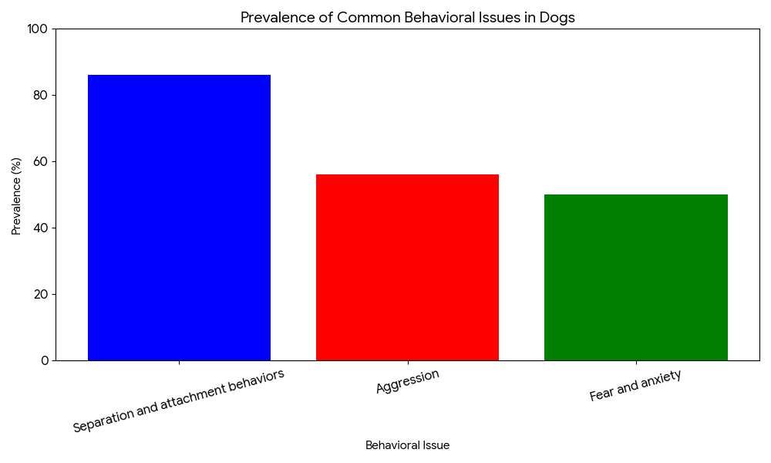  
*Fig: 1.0 graph demonstrates that separation and attachment behaviors are significantly more prevalent than aggression, fear, and anxiety among the sampled dogs*

Example: A rescue dog previously mistreated exhibits fear-based aggression. Ask Your Vet guides the caregiver through gradual desensitization exercises, reward-based training, and environmental adjustments to build trust.

# IV. REAL-LIFE CASE STUDIES AND USER SCENARIOS

*A. Case Study 1: Chronic Arthritis in a Senior Dog*

**Background:**

A 12-year-old Golden Retriever suffers from arthritis, resulting in stiffness and difficulty walking.

Consultation Approach: Ask Your Vet assists the caregiver in recognizing subtle signs of joint pain, recommends low-impact exercise routines, and suggests supplements such as glucosamine and chondroitin. A tailored pain management plan is created with veterinarian-approved medication schedules.

Outcome: The dog regains mobility, enjoys longer walks, and experiences improved quality of life without the need for invasive procedures.

### B. Case Study 2: Nutritional Imbalance in Cats

**Background**:

A household with multiple cats faces recurring health issues such as lethargy, hair loss, and digestive upset.

Consultation Approach: Ask Your Vet conducts a nutritional review and identifies that an all-dry food diet lacking moisture is contributing to urinary tract problems. The platform provides recommendations for introducing wet food and ensuring hydration while addressing common myths about diet changes.

Outcome: The cats show increased energy, improved coat condition, and fewer medical complications.

*C. Case Study 3: Behavioral Anxiety in Shelter Animals*

**Background:** A shelter managing dozens of rescue animals struggles with aggression and stress-related illnesses.

Consultation Approach: Ask Your Vet creates a structured environment plan, including feeding schedules, socialization routines, and enrichment activities. Staff training modules focus on compassionate handling techniques.

Outcome: Animal stress levels drop, adoption rates improve, and shelter workers report fewer injuries.

# V. ETHICAL GUIDELINES AND SAFETY PROTOCOLS

## *A. Ensuring Evidence-Based Advice*

Every recommendation provided by Ask Your Vet is backed by veterinary research and clinical experience. Information is regularly reviewed and updated to reflect current best practices. This commitment to an evidence-based approach means that we don't rely on tradition or personal opinion. Instead, our team of experts continuously analyzes the latest scientific literature, clinical trials, and data from professional veterinary associations to ensure all guidance is safe, effective, and aligned with the most current standards of care. This rigorous process guarantees that the advice you receive is credible and trustworthy..*(fig:1.1)*  
  
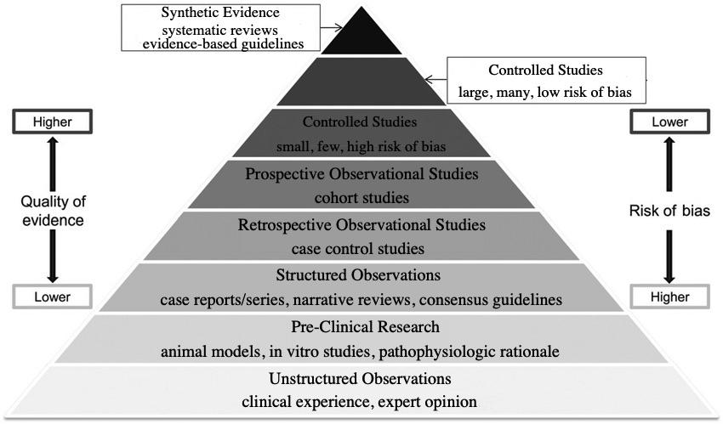

## Fig: 1.1: Hierarchy of evidence, from most available and least reliable at the bottom to most reliable and least available at the top B. Promoting Informed Consent

Users are encouraged to understand that some treatments may carry risks, and professional care should be sought when symptoms persist or worsen.

## C. Privacy and Confidentiality

User data, including medical history and consultation records, is encrypted and stored securely. Only authorized personnel can access sensitive information, and caregivers are educated on privacy policies.

# VI. TECHNOLOGICAL ADVANCEMENTS

The Ask Your Vet platform leverages modern cloud-based architecture to ensure reliable, scalable, and secure veterinary consultation services. The system design prioritizes user experience while maintaining robust backend functionality. 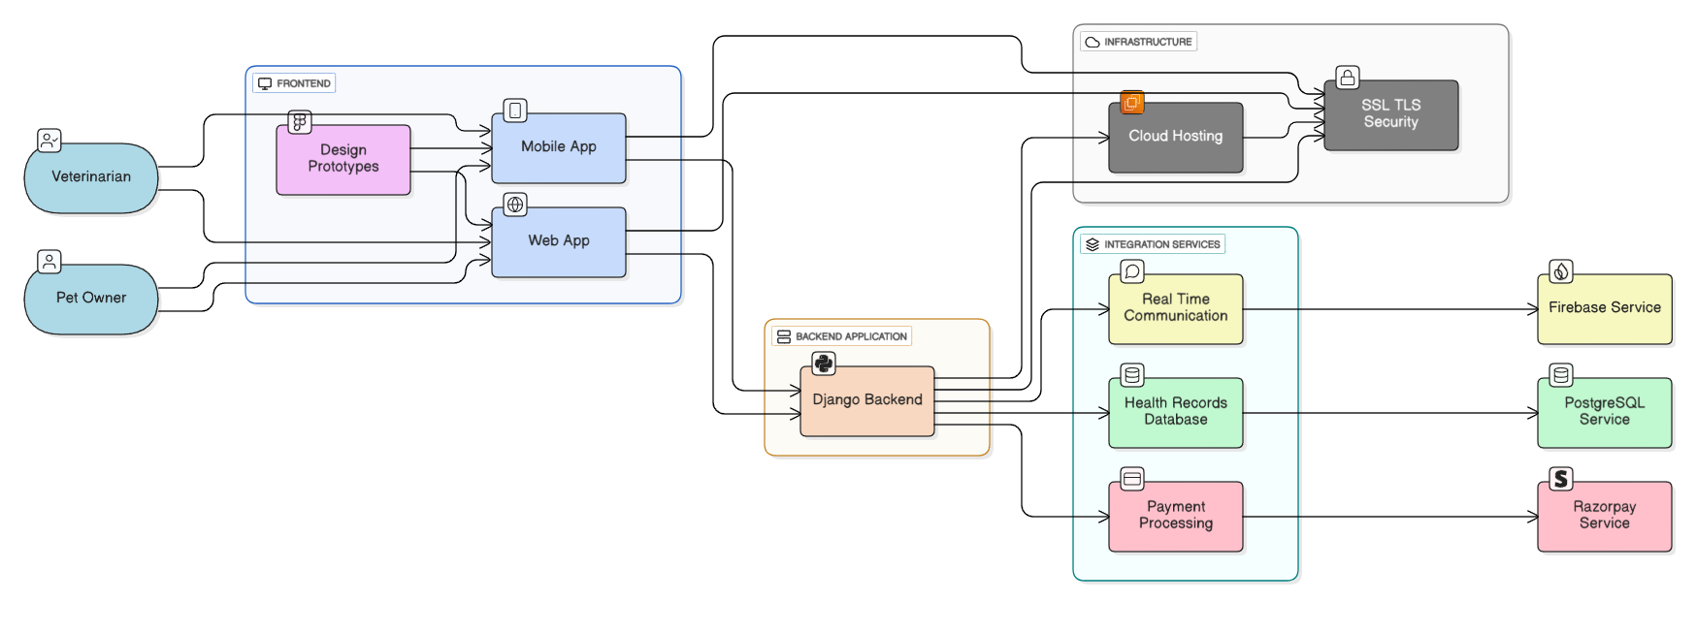  
*Fig. 1.2: Complete system architecture of the Ask Your Vet platform, illustrating the flow from user interfaces through backend processing to cloud infrastructure and third-party service integrations*

### A. Frontend Layer Architecture

The platform delivers seamless user experiences through multiple interface channels, each optimized for specific use cases and user preferences:

* **Mobile Application**: A native mobile application specifically designed for veterinarians and pet owners requiring on-the-go consultations. The mobile interface features intuitive touch-based navigation, camera integration for symptom documentation, push notifications for appointment reminders, and offline capability for basic information access.
* **Web Application**: A comprehensive browser-based interface providing full-featured desktop experience with advanced consultation tools, detailed health record management, administrative dashboards for veterinary practices, and multi-screen support for enhanced productivity.
* **Design Prototypes**: User-centered design methodology ensuring intuitive navigation patterns for both pet owners and veterinary professionals. The design system incorporates accessibility standards, responsive layouts across devices, consistent visual hierarchy, and streamlined user workflows that reduce consultation time while improving care quality.

### B. Backend Infrastructure and API Layer

The Django-based backend application serves as the core processing engine, providing enterprise-grade functionality and scalability:

* **RESTful API Architecture**: Comprehensive API endpoints enabling seamless data exchange between frontend applications and backend services. The API follows REST principles with proper HTTP status codes, standardized request/response formats, version control for backward compatibility, and comprehensive documentation for third-party integrations.
* **Authentication and Authorization Systems**: Multi-layered security framework implementing role-based access control (RBAC) for veterinarians, pet owners, and administrative users. Features include secure token-based authentication, OAuth integration for social login options, two-factor authentication for sensitive operations, and automated session management with configurable timeout policies.
* **Session Management and Request Handling**: Optimized request processing system designed to handle concurrent user sessions efficiently. The system implements connection pooling, request queuing mechanisms, load balancing across multiple server instances, and real-time performance monitoring with automatic scaling capabilities.
* **External Service Integration**: Robust integration layer facilitating communication with third-party services including payment gateways, notification systems, cloud storage providers, and veterinary laboratory networks for test result integration.

### C. Cloud Infrastructure and Security Framework

The platform is hosted on enterprise-grade cloud infrastructure ensuring maximum uptime, security, and scalability:

* **Data Encryption and Transmission Security**: Implementation of SSL/TLS 1.3 encryption protocols for all data transmission between clients and servers. Additional security measures include end-to-end encryption for sensitive health records, secure key management systems, and regular security audits and penetration testing.
* **Scalable Hosting Solutions**: Auto-scaling cloud infrastructure capable of handling variable user loads from single consultations to thousands of concurrent users. The system features horizontal scaling capabilities, load balancer configuration, content delivery network (CDN) integration for global performance, and geographic redundancy for disaster recovery.
* **Data Protection and Compliance**: Comprehensive backup and disaster recovery protocols with automated daily backups, point-in-time recovery capabilities, and compliance with veterinary data protection standards including HIPAA-equivalent requirements for animal health records.
* **Performance Monitoring**: Real-time system monitoring and alerting mechanisms ensuring optimal platform performance, proactive issue detection, and minimal service disruption.

### D. Integrated Services and External APIs

The platform incorporates specialized third-party services to enhance functionality and user experience:

* **Real-Time Communication Services**: Firebase-powered communication infrastructure enabling instant messaging between veterinarians and pet owners, high-quality video consultations with screen sharing capabilities, file sharing for medical documents and images, and group consultation features for complex cases requiring multiple specialists.
* **Health Records Database Management**: PostgreSQL-based database system providing secure storage and efficient retrieval of comprehensive animal health data. Features include encrypted data storage, automated backup systems, query optimization for large datasets, and integration with veterinary practice management systems.
* **Payment Processing Integration**: Secure Razorpay gateway implementation supporting multiple payment methods including credit/debit cards, digital wallets, and bank transfers. The system ensures PCI DSS compliance, automated invoice generation, subscription management for ongoing care plans, and transparent fee structures.
* **Notification and Alert System**: Comprehensive notification infrastructure powered by Firebase Cloud Messaging, delivering appointment reminders, medication alerts, follow-up care notifications, and emergency communication channels with customizable notification preferences and multi-channel delivery options.

### E. System Performance and Reliability

This carefully architected system ensures that Ask Your Vet can efficiently handle concurrent users while maintaining strict data integrity and providing consistently responsive user experiences across all touchpoints. The platform's modular architecture allows for independent scaling of different components based on demand, ensuring optimal resource utilization and cost-effectiveness.

Key performance characteristics include sub-second response times for standard queries, 99.9% uptime guarantee, automatic failover capabilities, and seamless updates without service interruption. The architecture's flexibility supports future enhancements and integrations while maintaining backward compatibility and system stability.

## A. AI and Predictive Analytics

Future updates to Ask Your Vet include artificial intelligence that can identify symptom patterns and recommend early interventions, potentially preventing diseases before they manifest.

## B. Wearable Technology for Animals

Integrating smart collars and health monitors can provide continuous data on activity, sleep, and physiological changes, allowing caregivers to respond quickly to anomalies.

## C. Teleconsultation Options

For remote areas lacking veterinary services, the platform will offer video consultations, enabling veterinarians to guide caregivers in real-time while preparing for on-site visits.

# VII. USER ENGAGEMENT AND COMMUNITY SUPPORT

Ask Your Vet is not just a consultation service; it is a community where caregivers can share experiences, advice, and encouragement. Features such as forums, live Q&A sessions, and educational webinars create a supportive environment where learning is continuous and inclusive.

Beyond these features, the platform fosters a sense of belonging through a few key initiatives:

* Peer-to-Peer Forums: The forums are moderated by veterinary professionals to ensure all information shared is safe and accurate. This allows users to connect with others who have pets with similar health issues, from managing chronic conditions to navigating puppyhood challenges.
* Expert-Led Events: Regular live Q&A sessions and webinars are hosted by specialists, offering direct access to veterinary dermatologists, nutritionists, and behaviorists. These sessions cover a range of topics, including the latest in preventive care and advanced treatment options. They also provide a space for users to ask questions in real-time, receiving personalized advice in a group setting.
* Success Stories and Testimonials: The platform highlights success stories from the community, showcasing positive health outcomes and behavioral improvements. This not only builds trust but also provides inspiration and hope for caregivers dealing with difficult situations.

By integrating these features, Ask Your Vet transforms from a simple service into a robust support system, recognizing that a pet’s well-being is often a collaborative effort between professionals and a dedicated community of caregivers.

# VIII. CONCLUSION

Ask Your Vet stands as a beacon for improving animal care worldwide. By integrating expert knowledge, preventive strategies, personalized advice, and community-driven resources, it empowers caregivers to provide holistic, compassionate, and scientifically sound care for their animals. Whether addressing routine wellness or managing chronic conditions, Ask Your Vet ensures that every animal receives the care, love, and attention it deserves.

Through ongoing innovation, ethical practices, and educational outreach, Ask Your Vet is positioned to revolutionize veterinary consultation, transforming how caregivers support animal health and welfare for generations to come.

References

*[1] American Veterinary Medical Association, “Veterinary Telehealth: The Basics.” [Online]. Available:* [*https://www.avma.org/resources-tools/animal-health-and-welfare/telehealth-telemedicine-veterinary-practice/veterinary-telehealth-basics*](https://www.avma.org/resources-tools/animal-health-and-welfare/telehealth-telemedicine-veterinary-practice/veterinary-telehealth-basics)

*[2] B. A. Albadrani, M. A. Abdel-Raheem, and M. I. Al-Farwachi, “Veterinary telemedicine: A new era for animal welfare,” Open Veterinary Journal, vol. 14, no. 4, Apr. 2024. [Online]. Available:* [*https://www.ncbi.nlm.nih.gov/pmc/articles/PMC11128645/*](https://www.ncbi.nlm.nih.gov/pmc/articles/PMC11128645/)

*[3] L. M. Teller, “Exploring the challenges and opportunities presented by veterinary telemedicine,” Vet. Rec., Sep. 2022. [Online]. Available:* [*https://www.researchgate.net/publication/363420225_Exploring_the_challenges_and_opportunities_presented_by_veterinary_telemedicine*](https://www.researchgate.net/publication/363420225_Exploring_the_challenges_and_opportunities_presented_by_veterinary_telemedicine)

*[4] D. Levine, A. P. Markley, D. J. Marcellin-Little, and H. Reesink, “Editorial: Sports medicine and physical rehabilitation, volume III,” Frontiers in Veterinary Science, vol. 12, p. 1551208, Feb. 2025. [Online]. Available:* [*https://pmc.ncbi.nlm.nih.gov/articles/PMC11880228/*](https://pmc.ncbi.nlm.nih.gov/articles/PMC11880228/)

*[5] T. Atalaia, J. Prazeres, J. Abrantes, and H. M. Clayton, “Equine Rehabilitation: A Scoping Review of the Literature,” Animals, vol. 11, no. 6, p. 1508, May 2021. [Online]. Available:* [*https://www.mdpi.com/2076-2615/11/6/1508*](https://www.mdpi.com/2076-2615/11/6/1508)

*[6] D. S. Kronfeld, P. L. Ferrante, and D. Grandjean, “Optimal Nutrition for Athletic Performance, with Emphasis on Fat Adaptation in Dogs and Horses,” Journal of Nutrition, vol. 124, no. 12, pp. 2745S–2753S, Jan. 1995. [Online]. Available:* [*https://pubmed.ncbi.nlm.nih.gov/7996286/*](https://pubmed.ncbi.nlm.nih.gov/7996286/)

*[7] T. L. Richards, A. Rankovic, J. P. Cant, A. K. Shoveller, J. L. Adolphe, D. Ramdath, and A. Verbrugghe, “Effect of Total Starch and Resistant Starch in Commercial Extruded Dog Foods on Gastric Emptying in Siberian Huskies,” Animals, vol. 11, no. 10, p. 2928, Oct. 2021. [Online]. Available:* [*https://www.mdpi.com/2076-2615/11/10/2928*](https://www.mdpi.com/2076-2615/11/10/2928)

*[8] S. Burron, T. Richards, K. Patterson, C. Grant, N. Akhtar, L. Trevizan, W. Pearson, and A. K. Shoveller, “Safety of Dietary Camelina Oil Supplementation in Healthy, Adult Dogs,” Animals, vol. 11, no. 9, p. 2603, Jun. 2021. [Online]. Available:* [*https://www.mdpi.com/2076-2615/11/9/2603*](https://www.mdpi.com/2076-2615/11/9/2603)

*[9] J. Atwal, J. Stockman, M. Gilham, D. Allaway, H. Renfrew, A. M. Bakke, and P. Watson, “No Observed Adverse Effects on Health Were Detected in Adult Beagle Dogs When Fed a High-Calcium Diet for 40 Weeks,” Animals, vol. 11, no. 6, p. 1799, Jun. 2021. [Online]. Available:* [*https://pmc.ncbi.nlm.nih.gov/articles/PMC8234157/*](https://pmc.ncbi.nlm.nih.gov/articles/PMC8234157/)

*[10] C. Delsante, V. C. O’Leary, G. Biagi, M. Grandi, and F. Marelli, “An Online Survey of Pet Food Storage and Feeding Practices of Dog and Cat Owners,” Animals, vol. 11, no. 5, p. 1478, May 2021. [Online]. Available:*[*https://www.mdpi.com/2076-2615/11/5/1478*](https://www.mdpi.com/2076-2615/11/5/1478)

**Sanath . M** **(Student Member, IEEE)** was born in Bengaluru, India, in 2003. He is currently pursuing a Bachelor of Technology degree in data science at [Your University], Bengaluru, India. His major field of study is data science with applications in healthcare and digital systems.

He has worked on academic projects in data analytics, artificial intelligence, and cloud-based application development. His recent work includes developing a veterinary telemedicine platform, *Ask Your Vet: Health and Sports*, which integrates digital health records, real-time consultations, and sports medicine support for animals. His current research interests include telemedicine, digital healthcare platforms, data-driven decision systems, and AI for social good.

Mr. Sanath is a Student Member of the IEEE Computer Society. He has participated in innovation programs and university-level projects focused on technology for public service and sustainability



**Rajashree S (Student Member, IEEE)** was born in Chikkaballapur, India, in 2004. She is currently studying for a Bachelor of Technology degree in Computer Science and Engineering with a specialization in Data Science at [Your University], Bengaluru, India.

She has worked on projects in data analysis, machine learning, and web application development. One of her recent projects is *Ask Your Vet: Health and Sports*, a veterinary telemedicine platform that supports online consultations, health record management, and animal care. Her current interests include telemedicine, digital healthcare, artificial intelligence, and data-driven systems.

Ms. Rajashree is a Student Member of the IEEE Computer Society and has taken part in student projects and innovation activities that focus on using technology for social good.



**Niha Naaz (Student Member, IEEE)** was born in Mandya, India, in 2004. She is currently pursuing a Bachelor of Technology degree in Computer Science and Engineering with a specialization in Data Science at [Your University], Bengaluru, India.

She has worked on projects related to artificial intelligence, data processing, and web-based platforms. Her recent academic work includes developing smart applications that focus on healthcare and digital services. Her research interests include machine learning, data science applications, healthcare technology, and AI for social impact.

Ms. Niha is a Student Member of the IEEE Computer Society and has actively participated in academic projects, technical events, and innovation programs that aim to apply technology for community and educational development.

1.